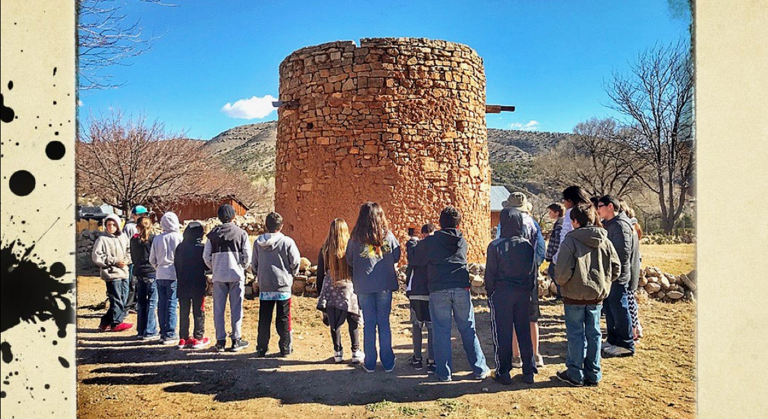
Overview: In this lesson, students will learn how the torreon in present-day Lincoln was built by settlers moving south from the upper Rio Grande. In it’s early years, the torreon in La Placita del Rio Bonito (later renamed Lincoln) was a refuge and place of defense for settlers against Native American raids, the dreaded Horrell brothers and the violence of the Lincoln County War.

Essential Question: What purpose did torreons serve for Native New Mexican Hispanic settlers in the early days of southern New Mexico?

Lockdown in Lincoln
Lincoln Historic Site
Tiffanie Owen, Instructional Coordinator

References Used in this Lesson:
Cozzens,Gary. (n.d.). “They Built the Torreon: The Miranda Family and Enrique Trujillo.” Lincoln Historic Site Education Files.

Eastwood, Rich. “Historic Lincoln, NM, The Buildings and People.” CreateSpace Independent Publishing Platform,.

“Lincoln County New Mexico Tells Its Stories.” Edited by Marilyn Burchett, Lincoln County Historical Society Publications, 2012.

Nolan, Frederick. “The West of Billy the Kid.” University of Oklahoma Press, 1998, p 155-166.

Students on a field trip ponder the purpose of the torreon at Lincoln Historic Site. Photo by Tiffanie Owen
Learning Objectives:
After completing this lesson, student will be able to:

- Understand the challenges faced by settlers in the early days of territorial New Mexico.
- Appreciate the origins and purpose of torreons and their structural design.
- Name the two “wars” that raged in Lincoln, New Mexico near the site of the historic torreon.
- Compare the differences between the re-built torreon that exists today and the original torreon built in the early 1850s.

Background:
Many of the early settlers in the Rio Bonito Valley arrived in the 1850s and came from the Socorro and Manzano areas of New Mexico. Shelter and safety were some of the first concerns settlers had to contend with when they arrived in a new place. Apache tribes already lived in much of the southwest and did not want new people moving into their land, hunting where they hunted, diverting water from the river or disturbing sacred sites.
Upon arrival in the place they named La Placita del Rio Bonito (the little village by the pretty river), the Hispanic settlers first built a round, rock and adobe structure, known as a torreon, for protection from Apache attacks. They built their homes, known as jacals (pronounced huh-call), near the torreon, establishing a compound around the homes with a high wall.
The torreon is approximately 2 stories tall and has three levels: the floor, the mid-level and the roof. The torreon had a fireplace for warmth and all the families in the community stayed inside the torreon at night because it was safer than their jacals. The women only brought food for the children, but during the day, the villagers would return to their jacals and their work in the fields.
Someone in the community was always watching for trouble and when the sentry sounded the alarm, the villagers would herd their livestock into the inner walls of the village compound, because the animals were usually their most valuable possessions. Then the men would occupy the top level of the torreon with their weapons, while the women and children huddled together on the ground level.
The torreon in Lincoln was built by Enrique Trujillo, with the help of other early settlers in La Placita (now Lincoln). The Lincoln torreon was also used for protection of Lincoln’s citizens during the Horrell and Lincoln County Wars. By the early 1900s, however, it was already in disrepair. In 1935, the Chaves County Historical Society repaired and rebuilt the torreon under the Federal Reconstruction Act. Today, Lincoln’s torreon still stands as a symbol of the challenges of life in early New Mexico.
Activity Introduction:
K-4- Creating a Safe Space Group Activity
5-8- Coil Pot Clay Model Torreon
9-12 - Mapping activity and Writing Assignment

Social Studies Standards
Grades K-4

STRAND: History

Content Standard I: Students are able to identify important people and events in order to analyze significant patterns, relationships, themes, ideas, beliefs, and turning points in New Mexico, United States, and world history in order to understand the complexity of the human experience.

K-4 Benchmark I-A—New Mexico: Describe how contemporary and historical people and events have influenced New Mexico communities and regions.

K-4 Grade Performance Standards
(2nd Grade) 1. Describe how historical people, groups, and events have influenced the local community.
(3rd Grade) 1. Describe how the lives and contributions of people of New Mexico influenced local communities and regions.
(4th Grade) 1. Identify important issues, events, and individuals from New Mexico pre-history to the present.

STRAND: History

Content Standard I: Students are able to identify important people and events in order to analyze significant patterns, relationships, themes, ideas, beliefs, and turning points in New Mexico, United States, and world history in order to understand the complexity of the human experience.

K-4 Benchmark I-B—United States: Understand connections among historical events, people, and symbols significant to United States history and cultures.

K-4 Grade Performance Standards

(3rd Grade) 1. Describe local events and their connections to state history.
(4th Grade) 1. Describe local events and their connections and relationships to national history.

STRAND: History

Content Standard I: Students are able to identify important people and events in order to analyze significant patterns, relationships, themes, ideas, beliefs, and turning points in New Mexico, United States, and world history in order to understand the complexity of the human experience.

K-4 Benchmark I-C—World: Students will identify and describe similar historical characteristics of the United States and its neighboring countries.

K-4 Grade Performance Standards

(3rd Grade) 1. Identify and compare components that create a community in the United States and it’s neighboring countries.
(4th Grade) 1. Explain how historical events, people, and culture influence present day Canada, Mexico, and the United States (e.g. food, art, shelter, language).

STRAND: History

Content Standard I: Students are able to identify important people and events in order to analyze significant patterns, relationships, themes, ideas, beliefs, and turning points in New Mexico, United States, and world history in order to understand the complexity of the human experience.

K-4 Benchmark I-D—Skills: Understand time passage and chronology.

K-4 Grade Performance Standards

(Kindergarten) 1. Understand the concept of past and present.
(2nd Grade) 1. Correctly sequence historical events.
(3rd Grade) 1. Interpret information from multiple resources and contexts to determine chronological relationships.
(4th Grade) 1. Describe and explain how historians and archaeologists provide information about people in different time periods.
STRAND: Geography

Content Standard II: Students understand how physical, natural, and cultural processes influence where people live, the ways in which people live, and how societies interact with one another and their environments.

K-4 Benchmark II-B: Distinguish between natural and human characteristics of places and use this knowledge to define regions, their relationships with other regions, and patterns of change.

K-4 Grade Performance Standards

(2th Grade) 1. Describe how climate, natural resources, and natural hazards affect activities and settlement patterns.
2. Explain how people depend on the environment and its resources to satisfy their basic needs.

STRAND: Geography

Content Standard II: Students understand how physical, natural, and cultural processes influence where people live, the ways in which people live, and how societies interact with one another and their environments.

K-4 Benchmark II-C: Be familiar with aspects of human behavior and man-made and natural environments in order to recognize their impact on the past and present.

K-4 Grade Performance Standards

(1st Grade) 1. Identify examples of and uses for natural resources in the community, state, and nation. 2. Describe the human characteristics of places such as housing types and professions.

(2nd Grade) 1. Identify ways in which people depend on natural and man-made environments including natural resources to meet basic needs. (3rd Grade) 2. Identify ways in which people have modified their environments (e.g., building roads, clearing land for development, mining and constructing towns and cities). (4th Grade) 1. Explain how geographic factors have influenced people, including settlement patterns and population distribution in New Mexico, past and present. 2. Describe how environments, both natural and man-made, have influenced people and events over time, and describe how places change.
STRAND: Geography

Content Standard II: Students understand how physical, natural, and cultural processes influence where people live, the ways in which people live, and how societies interact with one another and their environments.

K-4 Benchmark II-E: Describe how economic, political, cultural, and social processes interact to shape patterns of human populations, and their interdependence, cooperation, and conflict.

K-4 Grade Performance Standards

(Kindergarten) 1. Identify classroom population. (1st Grade) 1. Identfy characteristics of culture (e.g. language, customs, religion, shelter). (2nd Grade) 1. Describe how characteristics of culture affect behaviors and lifestyles. (3rd Grade) 1. Describe how patterns of culture vary geographically. 2. Describe how transportation and communication networks are used in daily life. 3. Describe how cooperation and conflict affect neighborhoods and communities. (4th Grade) 1. Describe how cultures change. 3. Describe types and patterns of settlements.
STRAND: Geography

Content Standard II: Students understand how physical, natural, and cultural processes influence where people live, the ways in which people live, and how societies interact with one another and their environments.

K-4 Benchmark II-F: Describe how natural and man-made changes affect the meaning, use, distribution and value of resources.

K-4 Grade Performance Standards

(Kindergarten) 1. Identify natural resources.
(1st Grade) 1. Describe the role of resources in daily life.
2. Describe ways that humans depend upon, adapt to and affect the physical environment.

Social Studies Standards
Grades 5-8
STRAND: History

Content Standard I: Students are able to identify important people and events in order to analyze significant patterns, relationships, themes, ideas, beliefs, and turning points in New Mexico, United States, and world history in order to understand the complexity of the human experience.

5-8 Benchmark 1-A. New Mexico: explore and explain how people and events have influenced the development of New Mexico up to the present day.

5-8 Grade Performance Standards

(5th Grade) 1. describe changes of governance of New Mexico (e.g., indigenous, Spanish, Mexican, French, Texan, confederate, United States)
(7th Grade) 4. describe how important individuals, groups and events impacted the development of New Mexico from 16th century to the present (e.g., Don Juan de Oñate, Don Diego de Vargas, pueblo revolt, Popé, 1837 revolt, 1848 rebellion, treaty of Guadalupe Hildago, William Becknell and the Santa Fe trail, buffalo soldiers, Lincoln county war, Navajo long walk, Theodore Roosevelt and the rough riders, Robert Goddard, J. Robert Oppenheimer, Smokey Bear, Dennis Chavez, Manuel Lujan, Manhattan project, Harrison Schmitt, Albuquerque international balloon fiesta); 6. explain the impact of New Mexico on the development of the American west up to the present, to include: availability of land (e.g., individual, government, railroad, tribal, etc.); government land grants/treaties; transportation (e.g., wagons, railroads, automobile); identification and use of natural and human resources; population growth and economic patterns; and cultural interactions among indigenous and arriving populations and the resulting changes.
(8th Grade) 1. compare and contrast the settlement patterns of the American southwest with other regions of the United States.

STRAND: History

Content Standard I: Students are able to identify important people and events in order to analyze significant patterns, relationships, themes, ideas, beliefs, and turning points in New Mexico, United States, and world history in order to understand the complexity of the human experience.

5-8 Benchmark 1-B. United States: analyze and interpret major eras, events and individuals from the periods of exploration and colonization through the civil war and reconstruction in United States history.

5-8 Grade Performance Standards

(7th Grade) 1. analyze United States political policies on expansion of the United States into the southwest (e.g., Mexican cession, Gadsden purchase, broken treaties, long walk of the Navajos).
(8th Grade) 5. describe, explain and analyze the aims and impact of western expansion and the settlement of the United States.

STRAND: History

Content Standard I: Students are able to identify important people and events in order to analyze significant patterns, relationships, themes, ideas, beliefs, and turning points in New Mexico, United States, and world history in order to understand the complexity of the human experience.

5-8 Benchmark 1-D. Skills: research historical events and people from a variety of perspectives:

5-8 Grade Performance Standards

(5th Grade) 1. differentiate between, locate and use primary and secondary sources (e.g., computer software, interviews, biographies, oral histories, print, visual material, artifacts) to acquire information; 2. use resources for historical information (e.g., libraries, museums, historical societies, courthouse, worldwide web, family records, elders); 3. gather, organize and interpret information using a variety of media and technology.
(6th Grade) 1. organize information by sequencing, categorizing, identifying cause-and-effect relationships, comparing and contrasting, finding the main idea, summarizing, making generalizations and predictions, drawing inferences and conclusions.
(7th Grade) 2. demonstrate the ability to examine history from the perspectives of the participants
(8th Grade) 1. demonstrate understanding and apply problem-solving skills for historical research, to include: use of primary and secondary sources; sequencing, posing questions to be answered by historical inquiry; collecting, interpreting and applying information; gathering and validating materials that present a variety of perspectives.

STRAND: Geography

5-8 Benchmark 2-B: explain the physical and human characteristics of places and use this knowledge to define regions, their relationships with other regions, and their patterns of change:

5-8 Grade Performance Standards

(5th Grade) 1. describe human and natural characteristics of places.
(6th Grade) 1. explain how places change due to human activity.
(7th Grade) 1. select and explore a region by its distinguishing characteristics; 2. describe the role of technology in shaping the characteristics of places.
(8th Grade) 1. describe how individual and cultural characteristics affect perceptions of locales and regions; and 2. describe political, population and economic regions that result from patterns of human activity, using New Mexico as an example.

NM Core Arts Standards
Grades 5-8

Creating – Conceiving and developing new artistic ideas and work.
Anchor Standard #1. Generate and conceptualize artistic ideas and work.
Anchor Standard #2. Organize and develop artistic ideas and work.
Anchor Standard #3. Refine and complete artistic work.
Responding – Understanding and evaluating how the arts convey meaning. Anchor Standard #7.
Perceive and analyze artistic work.
Anchor Standard #8. Interpret intent and meaning in artistic work. Connecting – Relating artistic ideas and work with personal meaning and external context.
Anchor Standard #10 – Synthesize and relate knowledge and personal experiences to make art. Anchor Standard #11 – Relate artistic ideas and works with societal, cultural and historical context to deepen understanding.

Social Studies Standards
Grades 9-12
STRAND: History

Content Standard I: Students are able to identify important people and events in order to analyze significant patterns, relationships, themes, ideas, beliefs, and turning points in New Mexico, United States, and world history in order to understand the complexity of the human experience.

9-12 Benchmark 1-A. New Mexico: analyze how people and events of New Mexico have influenced United States and world history since statehood:

9-12 Performance Standards

2. Analyze the geographic, economic, social and political factors of New Mexico that impact United States and world history, to include: d. role of the federal government (e.g., military bases, national laboratories, national parks, Indian reservations, transportation systems, water projects).

STRAND: History

Content Standard I: Students are able to identify important people and events in order to analyze significant patterns, relationships, themes, ideas, beliefs, and turning points in New Mexico, United States, and world history in order to understand the complexity of the human experience.

9-12 Benchmark 1-B. United States: analyze and evaluate the impact of major eras, events and individuals in United States history since the civil war and reconstruction:

9-12 Performance Standards
9. Explain how United States history represents a framework of knowledge and skills within which to understand the complexity of the human experience, to include: a. analyze perspectives that have shaped the structures of historical knowledge; b. describe ways historians study the past; c. explain connections made between the past and the present and their impact.

Language Arts Standards
Grades 9-12
STRAND: Writing Standard: Text Types and Purposes 9-12 Grade Common Core Standard:
(9th-12th Grade) 3. Write narratives to develop real or imagined experiences or events using effective technique, well-chosen details, and well-structured event sequences. 4. Produce clear and coherent writing in which the development, organization and style are appropriate to task, purpose and audience. 5. Develop and strengthen writing as needed by planning, revising, editing, rewriting or trying a new approach, focusing on addressing what is most significant for a specific purpose and audience.

